Group Members: Micah Noland, Forest Flodin, William Lee, Samantha Szymczak

Prototype Screen Shots

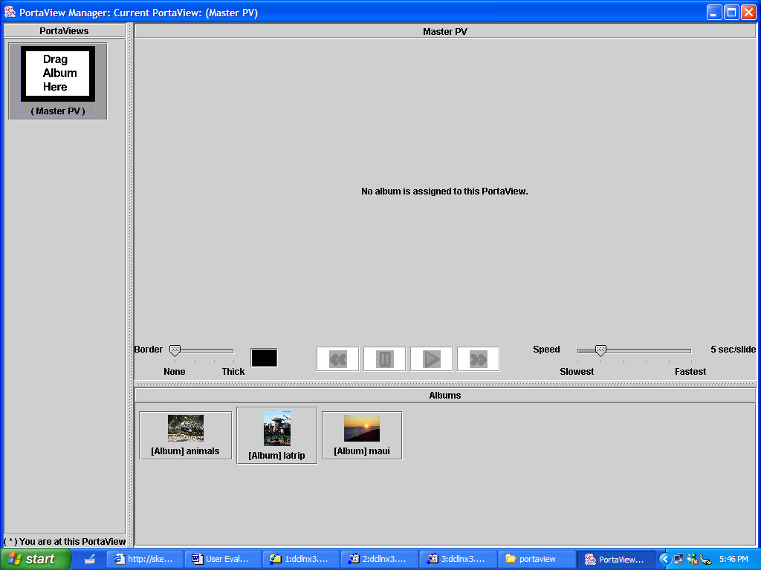
Figure 1: Opening PV View

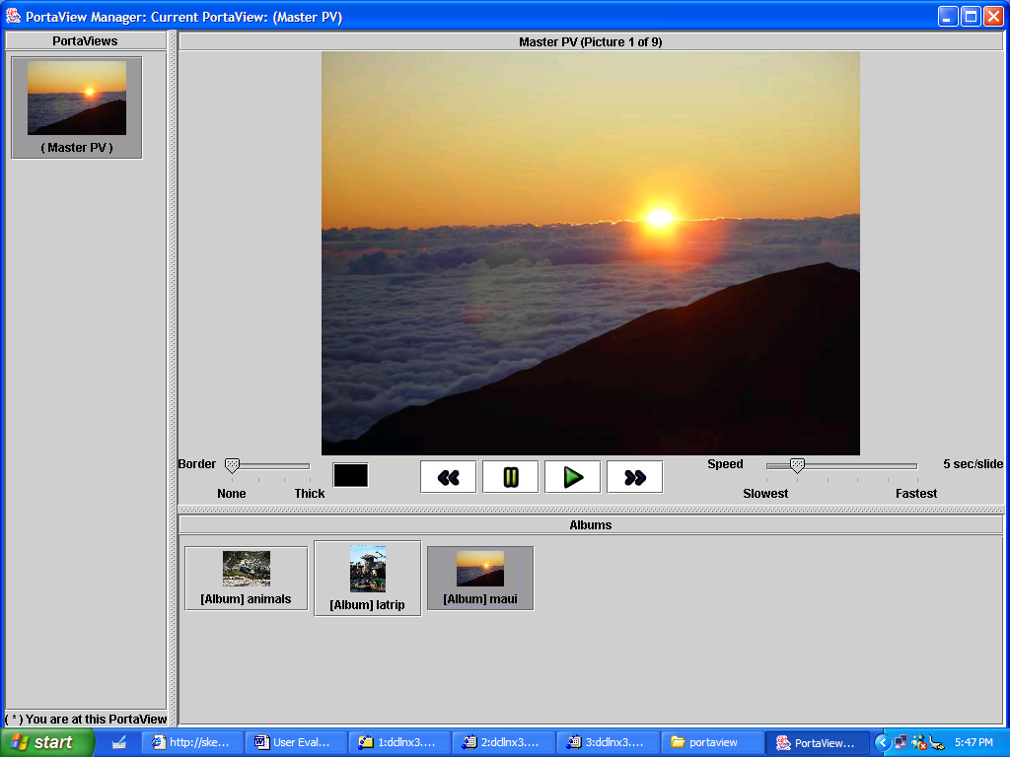
Figure 2: Maui Album set to Master PV

The above two pictures are screen shots from our prototype. When the Master PortaView is networked with another PortaView, additional PortaView buttons appear in the left panel.

Issues with Prototype
- Networking code takes more time to write than expected. PortaView uses a complicated peer-to-peer networking model. Preserving the networking transparency across PortaViews is more complicated than anticipated.
SOLUTION: An external XMLRPC server/client implementation is used to alleviate us from unnecessary coding efforts.

- Redraw semantics of Swing widgets were somewhat complicated. There still exists bugs in refreshing the PortaView panels.
SOLUTION: More testing is necessary in order to call the ‘repaint’ functions for various widgets in correct order.

- PortaView uses MVC model extensively. Although using the ‘Observer’ and ‘Observable’ classes in Java is fairly straightforward, it is sometimes hard to use MVC on a hierarchy of models and views. Also, in Java it is somewhat difficult to separate the models from views, since often you create the listeners using anonymous classes in the views.
SOLUTION: Forcefully make the listener classes call the controller code.

- It is sometimes difficult to layout the widgets in Java in order to mimic what we drew in our functional prototype.
SOULTION: Several iterations are necessary in order to try out what widgets would fit our model. We can validate our choices after user evaluations.

- Due to time constraints, we were unable to implement the extra “All PortaViews” and “Random” features in our prototype.
SOLUTION: These will more than likely not be implemented, as our attention is more focused on the current functionality and interface.

Goals of User Evaluations
As mentioned above, the layout of our coded prototype does not match the layout of our functional prototype exactly. In order to test the effectiveness of our coded interface and functionality, we have outlined specific goals below:

- Can user display given album on desired PortaView?
- Can user adjust PortaView settings?
- Can user identify status of master PortaView?
- Can user identify status of slave PortaViews?
- Can user toggle between manager view and display view?
- Does the functionality of our prototype match the expected functionality by the user?

Testing and Measuring Our Goals
The above goals will be tested by asking users to perform specific tasks (as described in more detail later in this report). We will measure the effectiveness of our prototype by the number of errors our interface causes our user to make. We will define an error as the top- level action that initiates the deviation from the defined correct functionality of our prototype. In the case of a question instead of an action to be performed, an error will be defined as a response not congruent with the actual defined behavior of our system. Below are the defined correct action paths and system responses.
- Display an album on a PortaView – Drag Album to PV button on left panel.
- Identify status of master and slave PortaViews – By inspection of thumbnail on left panel, or by clicking panel and displaying PV contents.
- Toggle between manager and display view – Click the “Full Screen View” button (not present yet in screen shot).
- Expected functionality of controls in top panel – boarder thickness slider, color picker for boarder, flip forward or backward through album, pause album slide show, begin slide show, adjust speed of slide show.

We will assume a usable interface if the tasks are achieved with no more than one error per task. We feel that this will reasonably show that our interface contains enough affordances for users to achieve their goals. Each error (sequence of actions or response) will be recorded. If it takes a user more than one error before achieving any of the above tasks, we will make changes to our interface accordingly.

We will also test to make sure our system behaves in accordance to the user’s predictions. If the same error is performed more than once on a single task, then we find it reasonable to assume our prototype’s response to input was not understood. In other words, if the response (or lack of response) of our prototype to user input is not understood by the user such that he/she performs the same incorrect input twice, then we will find it necessary to make changes accordingly.

Finally, after the user has completed the tasks, we will ask him/her a few brief questions about the interface. These questions will be qualitative rather than quantitative and will be taken into account as we make our final adjustments to the interface

Evaluation Schedule
The User Evaluations are scheduled for Sunday November 16th, 2003 at 4:00pm and 6:00pm. Our project team will meet with each user at their respective places of residence. The prototype medium will be the project team’s tablet PCs. One tablet will be set up with the master PortaView. The other tablets will be placed in the room as receivers in such a way that the user can see the response of his/her input on the system.

Evaluation Script

Orientation:
Carrie(Fred), thank you again for your time. This meeting will be similar to the previous. We have implemented a computer prototype of our system. We will simply ask you to perform a few tasks, and as before, the team will be observing and taking notes. Again, we’d like to stress that this is a test of our SYSTEM, and not you. All of the data collected will be confidential between the team members. A summary of our findings will be used and presented for our class project. Also, we strongly encourage you to verbalize your thought process. It will help us out tremendously if you explain what actions you’re going to take and why, what outcomes you expect to happen. Let us know if you’re debating between actions, or find any ambiguity in the interface, or any conflicts between what you expected to happen and what really happens. We will go over the system again briefly. First, do you have any questions?

The system being used is the implemented version of the paper prototype we went over last time. This will be your Master PortaView (give them master PortaView already in manager view with 2 empty PVs, 1 PV set to “animals” album, and master PV set to “LA Trip” album.) Imagine that this is a hardware device that looks like the simulated hardware on the screen of this Tablet. Each of these three PortaViews (show them slave portaviews) are the PortaViews on display in your household. The master PortaView is used to manage the display on these PortaViews, as was the scenario with the paper prototype. We have already downloaded albums into the PortaView for you to use. We will begin with the tasks. First, do you have any questions about the system?

Tasks:
- Please take the time to look over the System. Once you are comfortable, can you tell us which, if any, album is displayed on each PortaView.
- Could you display the Maui Album on the Kitchen PortaView please?
- Can you walk us through each of these controls, and explain what you would expect them to do? (direct user to PV settings controls)
- If you were finished managing your albums among PortaViews, and ready to put your Master PortaView back on display, how would you go about returning to display view?
- Once in display view, can you return to manager view?

Questions:
- After experimenting with the PortaView on these previous tasks, is there anything about the interface that seems ambiguous? (that you don’t know what it’s for?)
- Did any of your actions during the tasks result in an unexpected outcome?
- Do you feel comfortable managing the albums in your PortaViews, or would you rather see a different functionality?
- Are there any actions that you thought the interface allowed, but it actually does not?
- Any other comments or feedback?
Roles of Group Memebers
All group members will be taking notes and watching for errors.

Will – Set up system and networking.
Sam – Conduct User Evaluation

If an unanticipated problem occurs, the User will be asked to state his/her expected outcome, and the evaluation will continue. If the problem prevents us from continuing through the evaluation, we will do our best to fix the technical problem. If it is unfixable at the time, we will thank the user for their time and try to use any data that we might have been able to obtain. If the user gets stuck on something, we will encourage him/her to verbalize his/her thoughts. If the user is still stuck, we will simply move on to the next task. If the user selects a non-functional feature, we will explain that it is not working properly, and ask him/her for his/her expected system response if the system was working.

All group members will convene after evaluation to compile notes and discuss results.

